Patient Name **: Mr SURENDRA SINGH**

DOB/Age/Gender` : 26 Y/Male

Patient ID / UHID : 2870306/OF2870306

Referred By : Dr.

Sample Type : Whole blood EDTA

Client : SHIV PATHOLOGY GWALIOR

Bill Date : Feb 10, 2023, 04:33 PM

Sample Collected : Feb 10, 2023, 04:33 PM

Sample Received : Feb 11, 2023, 01:44 PM

Report Date : Feb 11, 2023, 02:43 PM Barcode No : HT067222

Report Status : Final Report

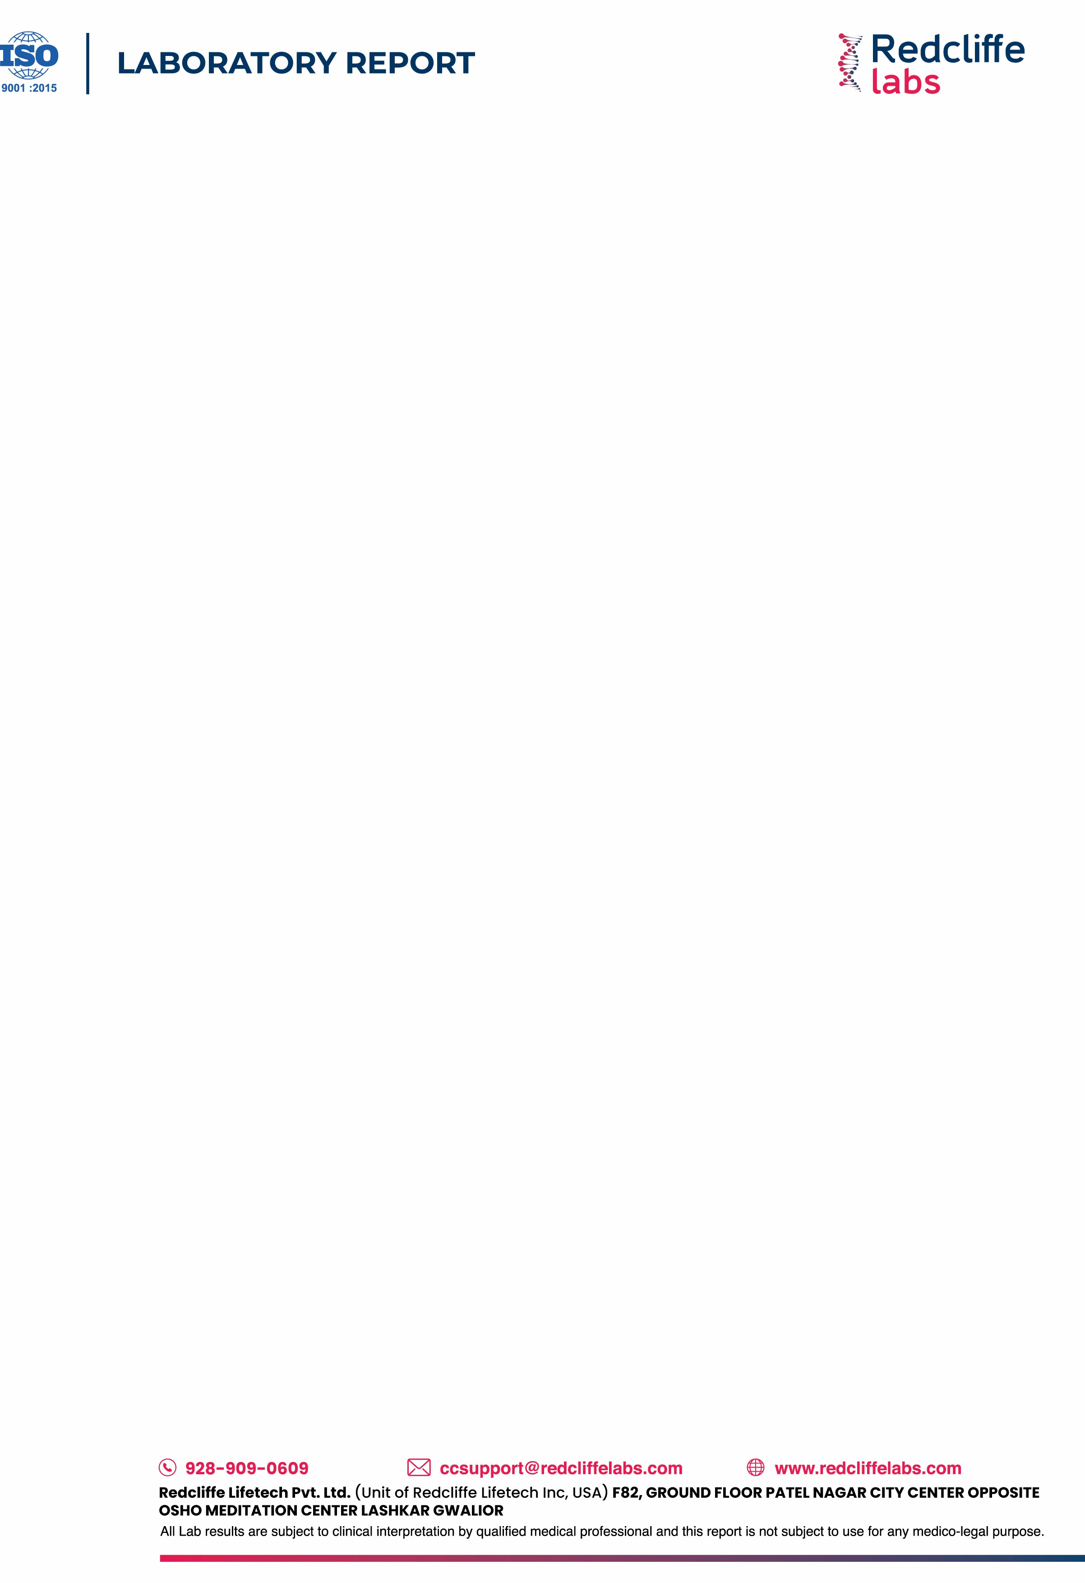

**Test Description Value(s) Unit(s) Reference Range**

# HEMATOLOGY REPORT

**Vital Screening Package Complete Blood Count (CBC)**

|  |  |  |  |
| --- | --- | --- | --- |
| **RBC PARAMETERS** |  | | |
| Hemoglobin  Method : colorimetric | 16.1 | g/dL | 13.0 - 17.0 |
| RBC Count  Method : Electrical impedance | 5 | 10^6/µl | 4.5 - 5.5 |
| PCV  Method : Calculated | 49.2 | % | 40 - 50 |
| MCV  Method : Calculated | 99.4 | fl | 83 - 101 |
| MCH  Method : Calculated | **32.6** | pg | 27 - 32 |
| MCHC  Method : Calculated | 32.8 | g/dL | 31.5 - 34.5 |
| RDW (CV)  Method : Calculated | 13.7 | % | 11.6 - 14.0 |
| RDW-SD  Method : Calculated | **48.5** | fl | 35.1 - 43.9 |
| **WBC PARAMETERS** |  |  |  |
| TLC  Method : Electrical impedance and microscopy | 8.1 | 10^3/µl | 4 - 10 |
| **DIFFERENTIAL LEUCOCYTE COUNT** |  |  |  |
| Neutrophils | 53.6 | % | 40-80 |
| Lymphocytes | 38.6 | % | 20-40 |
| Monocytes | 5.7 | % | 2-10 |
| Eosinophils | 2 | % | 1-6 |
| Basophils | 0.1 | % | <2 |
| **Absolute leukocyte counts**  **Method : Calculated** |  |  |  |
| Neutrophils* | 4.34 | 10^3/µl | 2 - 7 |
| Lymphocytes* | **3.13** | 10^3/µl | 1 - 3 |
| Monocytes* | 0.46 | 10^3/µl | 0.2 - 1.0 |
| Eosinophils* | 0.16 | 10^3/µl | 0.02 - 0.5 |
| Basophils* | **0.01** | 10^3/µl | 0.02 - 0.5 |
| **PLATELET PARAMETERS** |  |  |  |
| Platelet Count  Method : Electrical impedance and microscopy | 254 | 10^3/µl | 150 - 410 |
| Mean Platelet Volume (MPV) | 11.1 | fL | 9.3 - 12.1 |

Patient Name **: Mr SURENDRA SINGH**

DOB/Age/Gender` : 26 Y/Male

Patient ID / UHID : 2870306/OF2870306

Referred By : Dr.

Sample Type : Whole blood EDTA

Client : SHIV PATHOLOGY GWALIOR

Bill Date : Feb 10, 2023, 04:33 PM

Sample Collected : Feb 10, 2023, 04:33 PM

Sample Received : Feb 11, 2023, 01:44 PM

Report Date : Feb 11, 2023, 02:43 PM Barcode No : HT067222

Report Status : Final Report



|  |  |  |  |
| --- | --- | --- | --- |
| **Test Description** | **Value(s)** | **Unit(s)** | **Reference Range** |
| Method : Calculated |  |  |  |
| PCT  Method : Calculated | 0.3 | % | 0.17 - 0.32 |
| PDW  Method : Calculated | 15.2 | fL | 8.3 - 25.0 |
| P-LCR  Method : Calculated | 33.4 | % | 18 - 50 |
| P-LCC  Method : Calculated | 85 | % | 44 - 140 |
| Mentzer Index  Method : Calculated | 19.88 | % |  |

## Interpretation:

### CBC provides information about red cells, white cells and platelets. Results are useful in the diagnosis of anemia, infections, leukemias, clotting disorders and many other medical conditions.

Patient Name **: Mr SURENDRA SINGH**

DOB/Age/Gender` : 26 Y/Male

Patient ID / UHID : 2870306/OF2870306

Referred By : Dr.

Sample Type : Whole blood EDTA

Client : SHIV PATHOLOGY GWALIOR

Bill Date : Feb 10, 2023, 04:33 PM

Sample Collected : Feb 10, 2023, 04:33 PM

Sample Received : Feb 11, 2023, 01:44 PM

Report Date : Feb 11, 2023, 02:43 PM Barcode No : HT067222

Report Status : Final Report

**Test Description Value(s) Unit(s) Reference Range**

ESR - Erythrocyte Sedimentation Rate

Method : MODIFIED WESTERGREN

**Interpretation:**

# HEMATOLOGY REPORT

**Vital Screening Package Erythrocyte Sedimentation Rate (ESR)**

04 mm/hr 0 - 10

### Indicates presence and intensity of an inflammatory process; never diagnostic of a specific disease. ESR is increased in chronic inflammatory diseases, especially collagen and vascular diseases. Decreased ESR is seen in congestive heart failure, cachexia and after high dose of adrenal steroids.



Patient Name **: Mr SURENDRA SINGH**

DOB/Age/Gender` : 26 Y/Male

Patient ID / UHID : 2870306/OF2870306

Referred By : Dr.

Sample Type : Serum

Client : SHIV PATHOLOGY GWALIOR

Bill Date : Feb 10, 2023, 04:33 PM

Sample Collected : Feb 10, 2023, 04:33 PM

Sample Received : Feb 11, 2023, 01:44 PM

Report Date : Feb 11, 2023, 02:52 PM Barcode No : BH217085

Report Status : Final Report



**Test Description Value(s) Unit(s) Reference Range**

# BIOCHEMISTRY REPORT

**Vital Screening Package Liver Function Test (LFT)**

|  |  |  |  |
| --- | --- | --- | --- |
| BILIRUBIN TOTAL  Method : Photometric | 1.1 | mg/dL | 0.2 - 1.2 |
| BILIRUBIN DIRECT  Method : Diazo Reaction | 0.5 | mg/dL | 0.0 - 0.5 |
| BILIRUBIN INDIRECT  Method : Calculation (T Bil - D Bil) | 0.6 | mg/dL | 0.1 - 1.0 |
| SGOT/AST  Method : IFCC without P5P | 33 | U/L | 5 - 34 |
| SGPT/ALT  Method : IFCC without P5P | 35 | U/L | 0 to 55 |
| SGOT/SGPT Ratio | 0.94 | - | - |
| ALKALINE PHOSPHATASE  Method : IFCC | 59 | U/L | 40 - 150 |
| TOTAL PROTEIN  Method : Biuret | 7.6 | g/dL | 6.4 - 8.3 |
| ALBUMIN  Method : BCG | 5 | gm/dL | 3.8 - 5.0 |
| GLOBULIN  Method : Calculation (T.P - Albumin) | 2.6 | g/dL | 2.3 - 3.5 |
| ALBUMIN : GLOBULIN RATIO  Method : Calculation (Albumin/Globulin) | 1.92 | - | 1.0 - 2.1 |
| GAMMA GLUTAMYL TRANSFERASE (GGT)  Method : Photometric | 19 | U/L | 12 - 64 |

## Interpretation:

The liver filters and processes blood as it circulates through the body. It metabolizes nutrients, detoxifies harmful substances, makes blood clotting proteins, and performs many other vital functions. The cells in the liver contain proteins called enzymes that drive these chemical reactions. When liver cells are damaged or destroyed, the enzymes in the cells leak out into the blood, where they can be measured by blood tests Liver tests check the blood for two main liver enzymes. Aspartate aminotransferase (AST),SGOT: The AST enzyme is also found in muscles and many other tissues besides the liver. Alanine aminotransferase (ALT), SGPT: ALT is almost exclusively found in the liver. If ALT and AST are found together in elevated amounts in the blood, liver damage is most likely present. Alkaline Phosphatase and GGT: Another of the liver's key functions is the production of bile, which helps digest fat. Bile flows through the liver in a system of small tubes (ducts), and is eventually stored in the gallbladder, under the liver. When bile flow is slow or blocked, blood levels of certain liver enzymes rise: Alkaline phosphatase Gamma-utamyl transpeptidase (GGT) Liver tests may check for any or all of these enzymes in the blood. Alkaline phosphatase is by far the most commonly tested of the three. If alkaline phosphatase and GGT are elevated, a problem with bile flow is most likely present. Bile flow problems can be due to a problem in the liver, the gallbladder, or the tubes connecting them. Proteins are important building blocks of all cells and tissues. Proteins are necessary for your body's growth, development, and health. Blood contains two classes of protein, albumin and globulin. Albumin proteins keep fluid from leaking out of blood vessels. Globulin proteins play an important role in your immune system. Low total protein may indicate: 1.bleeding 2.liver disorder 3.malnutrition 4.agammaglobulinemia High Protein levels 'Hyperproteinemia: May be seen in dehydration due to inadequate water intake or to excessive water loss (eg, severe vomiting, diarrhea, Addison's disease and diabetic acidosis) or as a result of increased production of proteins Low albumin levels may be caused by: 1.A poor diet (malnutrition). 2.Kidney disease. 3.Liver disease. High albumin levels may be caused by: Severe dehydration.

Patient Name **: Mr SURENDRA SINGH**

DOB/Age/Gender` : 26 Y/Male

Patient ID / UHID : 2870306/OF2870306

Referred By : Dr.

Sample Type : Serum

Client : SHIV PATHOLOGY GWALIOR

Bill Date : Feb 10, 2023, 04:33 PM

Sample Collected : Feb 10, 2023, 04:33 PM

Sample Received : Feb 11, 2023, 01:44 PM

Report Date : Feb 11, 2023, 02:52 PM Barcode No : BH217085

Report Status : Final Report



**Test Description Value(s) Unit(s) Reference Range**

# BIOCHEMISTRY REPORT

**Vital Screening Package Kidney Function Test (KFT)**

|  |  |  |  |
| --- | --- | --- | --- |
| BLOOD UREA  Method : Urease | 24 | mg/dL | 19 - 44.1 |
| CREATININE  Method : Photometric | 0.89 | mg/dL | 0.72 - 1.25 |
| BUN  Method : Urease | 11.21 | mg/dL | 8.9 - 20.6 |
| BUN/CREATININE RATIO | 12.6 |  |  |
| UREA / CREATININE RATIO | 26.97 |  |  |
| URIC ACID  Method : Uricase | 6.3 | mg/dL | 3.5 - 7.2 |
| CALCIUM Serum  Method : Arsenazo III | 9.1 | mg/dL | 8.4 - 10.2 |
| PHOSPHORUS  Method : Photometric | 3.8 | mg/dL | 2.3 - 4.7 |
| SODIUM  Method : Potentiometric | 142.4 | mmol/L | 136 - 145 |
| POTASSIUM  Method : Potentiometric | 3.89 | mmol/L | 3.5 - 5.1 |
| CHLORIDE  Method : Photometric | 102.6 | mmol/L | 98 - 107 |

## Interpretation:

**SUMMARY:-**

Kidney function tests is a collective term for a variety of individual tests and proceduresthat can be done toevaluate how well the kidneys are functioning.Many conditions can affect the ability of the kidneys to carryout their vital functions. Somelead to a rapid (acute) decline in kidney functionothers lead to a gradual (chronic) declineinfunction. Both result in a buildup of toxic waste subst done on urine samples, as well as on blood samples.A number of symptoms may indicate a problem with your kidneys. These include : high blood pressure,blood in urine frequent urges to urinate,difficulty beginning urination,painful urination,swelling in the hands and feet due to a buildup of fluids in the body. A single symptom may not mean something serious. However, when occurring simultaneously, these symptoms suggest that your kidneys are not working properly. Kidney function tests can help determine the reason. Electrolytes (sodium,potassium,and chloride) are present in the human body and the balancing act of the electrolytes in our bodies is essential for normal function of our cells and organs. There has to be a balance.Ionized calcium this test if you have signs of kidney or parathyroid disease. The test may also be done to monitor progress and treatment of these diseases.

Patient Name **: Mr SURENDRA SINGH**

DOB/Age/Gender` : 26 Y/Male

Patient ID / UHID : 2870306/OF2870306

Referred By : Dr.

Sample Type : Serum

Client : SHIV PATHOLOGY GWALIOR

Bill Date : Feb 10, 2023, 04:33 PM

Sample Collected : Feb 10, 2023, 04:33 PM

Sample Received : Feb 11, 2023, 01:44 PM

Report Date : Feb 11, 2023, 02:52 PM Barcode No : BH217085

Report Status : Final Report



**Test Description Value(s) Unit(s) Reference Range**

# BIOCHEMISTRY REPORT

**Vital Screening Package Lipid Profile**

|  |  |  |  |
| --- | --- | --- | --- |
| TOTAL CHOLESTEROL  Method : Enzymatic - Cholesterol Oxidase | 145 | mg/dL | Desirable : <200  Borderline : 200-239  High : >240 |
| TRIGLYCERIDES  Method : Colorimetric - Lip/Glycerol Kinase | 105 | mg/dL | Normal : <150  Borderline : 150-199  High : 200-499  Very high : >500 |
| HDL CHOLESTEROL | 44 | mg/dL | >40 |
| Method : Accelerator Selective Detergent |  |  |  |
| NON HDL CHOLESTEROL | 101 | mg/dL | <130 |
| Method : Calculated |  |  |  |
| LDL CHOLESTEROL  Method : Calculated | 80 | mg/dL | Optimal <100  Near optimal/above optimal 100-129 Borderline high  130-159  High 160-189  Very high >190 |
| V.L.D.L CHOLESTEROL | 21 | mg/dL | < 30 |
| Method : Calculated |  |  |  |
| CHOL/HDL Ratio | **3.3** | - | 3.5 - 5.0 |
| Method : Calculated |  |  |  |
| HDL/ LDL RATIO  Method : Calculated | 0.55 | - | Desirable : 0.5 - 3.0  Borderline : 3.1 - 6.0 High : > 6.0 |
| LDL/HDL Ratio | 1.82 | - |  |
| Method : Calculated |  |  |  |

## Interpretation:

Lipid level assessments must be made following 9 to 12 hours of fasting, otherwise assay results might lead to erroneous interpretation. NCEP recommends of 3 different samples to be drawn at intervals of 1 week for harmonizing biological variables that might be encountered in single assays.

|  |  |  |  |  |
| --- | --- | --- | --- | --- |
| NATIONAL LIPID ASSOCIATION RECOMMENDATIONS (NLA-2014) | TOTAL CHOLESTEROL  in mg/dL | TRIGLYCERIDE in  mg/dL | LDL CHOLESTEROL in  mg/dL | NON HDL CHOLESTEROL  in mg/dL |
| Optimal | <200 | <150 | <100 | <130 |
| Above Optimal |  |  | 100-129 | 130 - 159 |
| Borderline High | 200-239 | 150-199 | 130-159 | 160 - 189 |
| High | >=240 | 200-499 | 160-189 | 190 - 219 |
| Very High | - | >=500 | >=190 | >=220 |

